Contents
Overview 1
Navigation 1
Add Override 2
Request Override 3
Maintain and Track Override 3

Overview

The Workgroup Override allows the user to override certain workgroup settings at an employee level.

Currently the only override setting being utilised is the Holiday Scheme. It is the Holiday Scheme which calculates when an employee is allowed to book leave and this is derived from the workgroup as default. In certain circumstances where multiple employees share the same workgroup, but have differing holiday terms, then the Holiday Scheme against the workgroup can be overridden at employee level and these are the steps covered in this guide.

Navigation

The workgroup override setting is currently maintained in the Back Office.

Navigate to: CoreTime/CoreRoster > Pers Data > Person Maintenance > Work Group Override

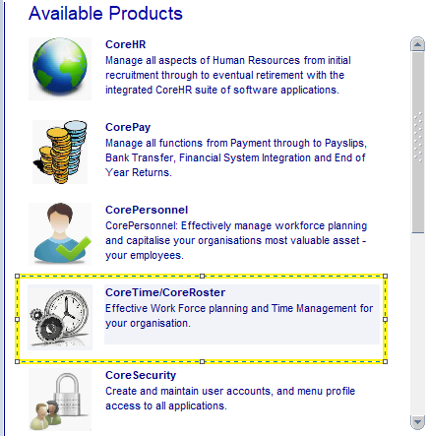

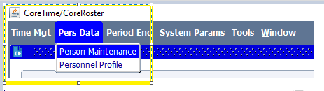

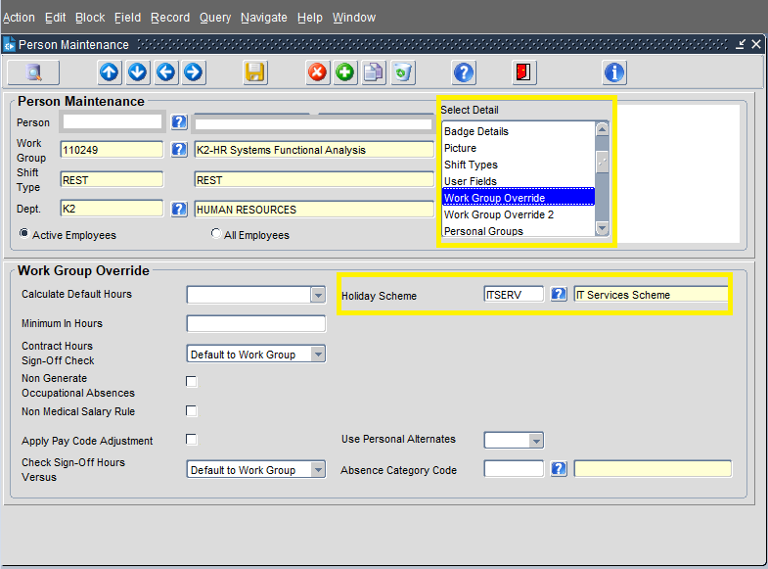

The screen displays the current workgroup assigned to the employee in the top section of the screen and any override settings displayed in the bottom section of the screen.

Add Override

From the CoreTime > Person Maintenance screen enter the personnel number into the Person field, or use the LOV button to search and select this.

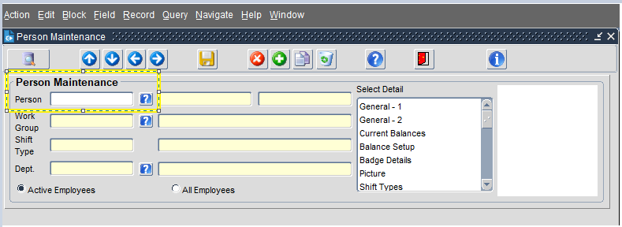

From the Select Details drop down menu click on Work Group Override.

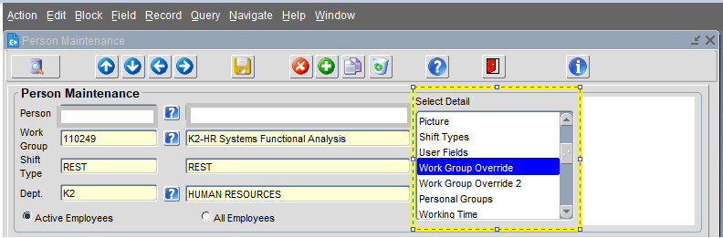

In the bottom section of the screen titled Work Group Override complete the Holiday Scheme field using the LOV to select an existing Holiday Scheme.

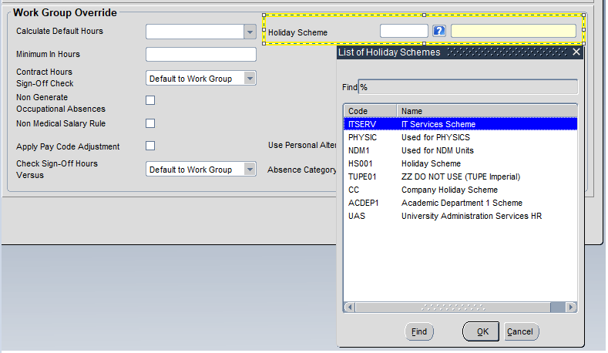

Click Save.

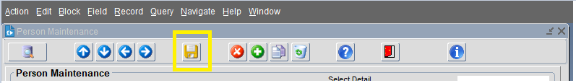

Request Override

**Process to be determined**

Maintain and Track Override

**Process to be determined**

